**PT. SITA RAM SHASTRI B.ED TRAINING COLLEGE**

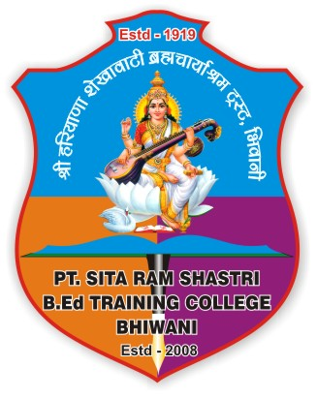

**( Recognized by N. C. T. E. & Affiliated to C.B.L.U. Bhiwani )**

**MEHAM GATE, BHIWANI (HARYANA) – 127021**

**‘B’ grade Accreditation by NAAC**

**E-mail –** [ptsrsb.edcollege@ymail.com](mailto:ptsrsb.edcollege@ymail.com)

**Ph. No. 07404201579**

# Annual Academic Calendar (2022-23)

*B.Ed. 2nd Year*

*Tentative Dates /Months*

|  |  |
| --- | --- |
| **Activities** | **Dates** |
| Admission B.Ed. 2nd Year | 01.09.2022- 15.09.2022 |
| Ideal Lesson | 16.09.2022- 17.09.2022 |
| Orientation Week | 19.09.2022- 24.09.2022 |
| Simulation (5+5 lessons for each pedagogy Subjects) | 27.09.2022- 01.10.2022 |
| 1st Discussion lesson | 3.10.2022 |
| Real Teaching Practice (12lessons) | 06.10.2022- 20.10.2022 |
| 2nd Discussion Lesson | 21.10.2022 |
| School Internship Period (1week) | 27.10.2022- 3.11.2022 |
| School Internship Period (15week) | 4.11.2022- 17.02.2023 |
| NSS Activities | 18.02.2023- 26.02.2023 |
| Commencement of Classes | 27.02.2023- 15.04.2023 |
| Unit Test | 16.042023- 20.04.2023 |
| commencement of Classes | 21.04.2023- 20.05.2023 |
| House Exam | 21.05.2023- 10.06.2023 |
| Remedial Teaching | 11.06.2023- 17.06.2023 |
| Dispersal of Classes | 17.06.2023 |
| final Examination (tentative) | 19.06.2023 onwards |
| Summer vacation | 19.06.2023- 31.07.2023 |

**Incharge**

**Ms. Ruchi**